**Exercise 1: Control Structures**

**Scenario 1:**

**BEGIN**

**FOR cust_rec IN (**

**SELECT CustomerID, Name, Age, InterestRate**

**FROM Customers**

**WHERE Age > 60**

**) LOOP**

**UPDATE Customers**

**SET InterestRate = InterestRate - 1**

**WHERE CustomerID = cust_rec.CustomerID;**

**DBMS_OUTPUT.PUT_LINE('Interest rate discounted for: ' || cust_rec.Name || ' (Customer ID: ' || cust_rec.CustomerID || ')');**

**END LOOP;**

**END;**

**/**

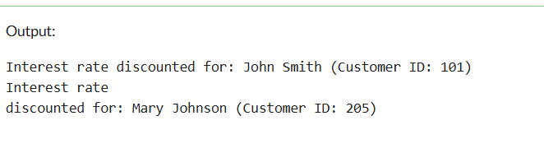

**Scenario 2:**

BEGIN

FOR cust_rec IN (

SELECT CustomerID, Name, Balance

FROM Customers

WHERE Balance > 10000

) LOOP

UPDATE Customers

SET IsVIP = 'Y'

WHERE CustomerID = cust_rec.CustomerID;

DBMS_OUTPUT.PUT_LINE('Customer promoted to VIP: ' || cust_rec.Name || ' (Customer ID: ' || cust_rec.CustomerID || ')');

END LOOP;

END;

/

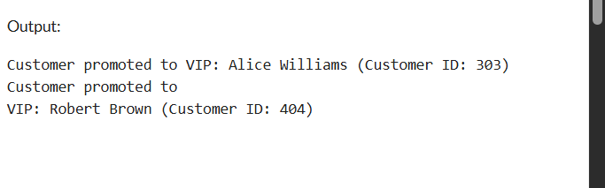

**Scenario 3:**

BEGIN

FOR loan_rec IN (

SELECT CustomerID, Name, LoanDueDate

FROM Customers

WHERE LoanDueDate BETWEEN SYSDATE AND SYSDATE + 30

) LOOP

DBMS_OUTPUT.PUT_LINE('Reminder: Loan due for ' || loan_rec.Name ||

' (Customer ID: ' || loan_rec.CustomerID ||

') on ' || TO_CHAR(loan_rec.LoanDueDate, 'DD-MON-YYYY'));

END LOOP;

END;

/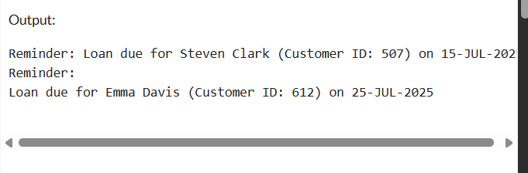

**Exercise 2: Error Handling**

**Scenario 1:**

CREATE OR REPLACE PROCEDURE SafeTransferFunds (

p_FromAccountID IN NUMBER,

p_ToAccountID IN NUMBER,

p_Amount IN NUMBER

)

AS

v_Balance NUMBER;

BEGIN

-- Get balance of from account

SELECT Balance INTO v_Balance

FROM Accounts

WHERE AccountID = p_FromAccountID;

IF v_Balance < p_Amount THEN

RAISE_APPLICATION_ERROR(-20001, 'Insufficient funds in the source account.');

END IF;

-- Deduct from sender

UPDATE Accounts

SET Balance = Balance - p_Amount

WHERE AccountID = p_FromAccountID;

-- Add to receiver

UPDATE Accounts

SET Balance = Balance + p_Amount

WHERE AccountID = p_ToAccountID;

COMMIT;

DBMS_OUTPUT.PUT_LINE('Transfer successful.');

EXCEPTION

WHEN OTHERS THEN

ROLLBACK;

INSERT INTO ErrorLog (ProcedureName, ErrorMessage)

VALUES ('SafeTransferFunds', SQLERRM);

DBMS_OUTPUT.PUT_LINE('Transfer failed: ' || SQLERRM);

END;

/

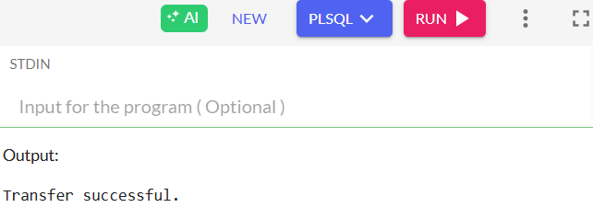

**Scenario 2:**

CREATE OR REPLACE PROCEDURE UpdateSalary (

p_EmployeeID IN NUMBER,

p_Percent IN NUMBER

)

AS

BEGIN

UPDATE Employees

SET Salary = Salary + (Salary * p_Percent / 100)

WHERE EmployeeID = p_EmployeeID;

IF SQL%ROWCOUNT = 0 THEN

RAISE_APPLICATION_ERROR(-20002, 'Employee not found.');

END IF;

COMMIT;

DBMS_OUTPUT.PUT_LINE('Salary updated successfully.');

EXCEPTION

WHEN OTHERS THEN

ROLLBACK;

INSERT INTO ErrorLog (ProcedureName, ErrorMessage)

VALUES ('UpdateSalary', SQLERRM);

DBMS_OUTPUT.PUT_LINE('Salary update failed: ' || SQLERRM);

END;

/

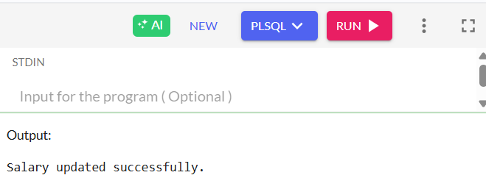

**Scenario 3:**

CREATE OR REPLACE PROCEDURE AddNewCustomer (

p_CustomerID IN NUMBER,

p_Name IN VARCHAR2,

p_Age IN NUMBER,

p_Balance IN NUMBER

)

AS

BEGIN

INSERT INTO Customers (CustomerID, Name, Age, Balance)

VALUES (p_CustomerID, p_Name, p_Age, p_Balance);

COMMIT;

DBMS_OUTPUT.PUT_LINE('Customer added successfully.');

EXCEPTION

WHEN DUP_VAL_ON_INDEX THEN

INSERT INTO ErrorLog (ProcedureName, ErrorMessage)

VALUES ('AddNewCustomer', 'Customer with ID ' || p_CustomerID || ' already exists.');

DBMS_OUTPUT.PUT_LINE('Add customer failed: Duplicate customer ID.');

WHEN OTHERS THEN

ROLLBACK;

INSERT INTO ErrorLog (ProcedureName, ErrorMessage)

VALUES ('AddNewCustomer', SQLERRM);

DBMS_OUTPUT.PUT_LINE('Add customer failed: ' || SQLERRM);

END;

/

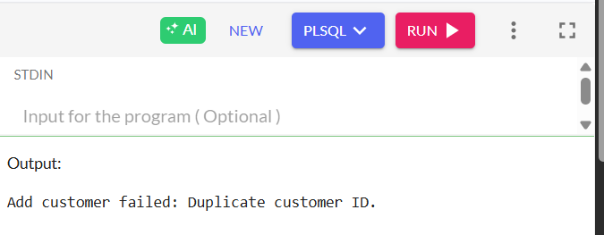

**Exercise 3: Stored Procedures**

**Scenario 1:**

CREATE OR REPLACE PROCEDURE ProcessMonthlyInterest

AS

BEGIN

FOR acc IN (SELECT AccountID, Balance FROM Accounts WHERE AccountType = 'Savings') LOOP

UPDATE Accounts

SET Balance = Balance + (Balance * 0.01)

WHERE AccountID = acc.AccountID;

DBMS_OUTPUT.PUT_LINE('Interest added to Account ID: ' || acc.AccountID ||

', New Balance: ' || TO_CHAR(acc.Balance * 1.01, '9999.99'));

END LOOP;

COMMIT;

END;

/

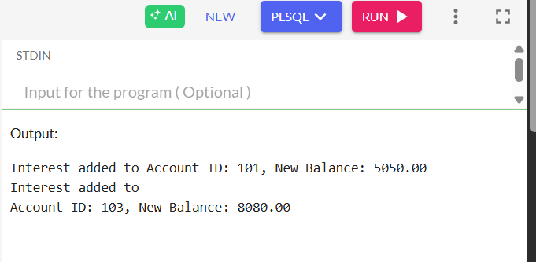

**Scenario 2:**

CREATE OR REPLACE PROCEDURE UpdateEmployeeBonus (

p_Department IN VARCHAR2,

p_BonusPct IN NUMBER

)

AS

BEGIN

FOR emp IN (SELECT EmployeeID, Name, Salary FROM Employees WHERE Department = p_Department) LOOP

UPDATE Employees

SET Salary = Salary + (Salary * p_BonusPct / 100)

WHERE EmployeeID = emp.EmployeeID;

DBMS_OUTPUT.PUT_LINE('Bonus applied to ' || emp.Name ||

', New Salary: ' || TO_CHAR(emp.Salary * (1 + p_BonusPct / 100), '99999.99'));

END LOOP;

COMMIT;

END;

/

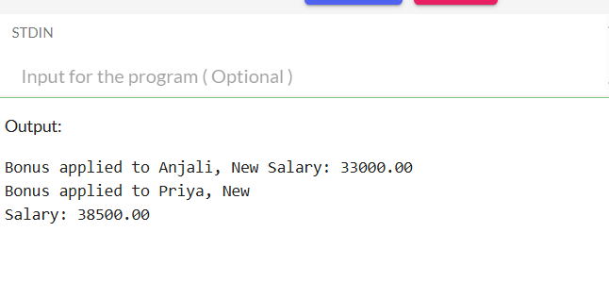

**Scenario 3:**

CREATE OR REPLACE PROCEDURE TransferFunds (

p_FromAccountID IN NUMBER,

p_ToAccountID IN NUMBER,

p_Amount IN NUMBER

)

AS

v_Balance NUMBER;

BEGIN

-- Check source balance

SELECT Balance INTO v_Balance

FROM Accounts

WHERE AccountID = p_FromAccountID;

IF v_Balance < p_Amount THEN

DBMS_OUTPUT.PUT_LINE('Transfer failed: Insufficient balance in Account ID ' || p_FromAccountID);

RETURN;

END IF;

-- Debit source

UPDATE Accounts

SET Balance = Balance - p_Amount

WHERE AccountID = p_FromAccountID;

-- Credit destination

UPDATE Accounts

SET Balance = Balance + p_Amount

WHERE AccountID = p_ToAccountID;

COMMIT;

DBMS_OUTPUT.PUT_LINE('Transfer successful: ₹' || p_Amount ||

' from Account ID ' || p_FromAccountID ||

' to Account ID ' || p_ToAccountID);

END;

/

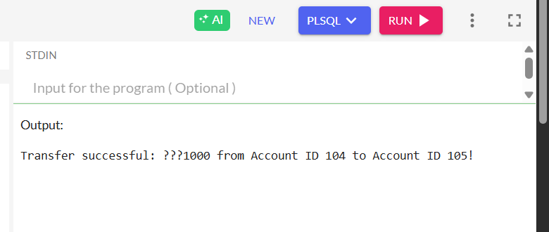

**Exercise 4: Functions**

Scenario 1:

CREATE OR REPLACE FUNCTION CalculateAge(p_DOB DATE)

RETURN NUMBER

IS

v_Age NUMBER;

BEGIN

v_Age := FLOOR(MONTHS_BETWEEN(SYSDATE, p_DOB) / 12);

RETURN v_Age;

END;

/

Scenario 2:

CREATE OR REPLACE FUNCTION CalculateMonthlyInstallment (

p_LoanAmount IN NUMBER,

p_AnnualRate IN NUMBER, -- Annual interest rate in percent

p_LoanYears IN NUMBER

) RETURN NUMBER

IS

v_MonthlyRate NUMBER;

v_Months NUMBER;

v_Installment NUMBER;

BEGIN

v_MonthlyRate := p_AnnualRate / (12 * 100); -- Convert to monthly rate

v_Months := p_LoanYears * 12;

v_Installment := p_LoanAmount * v_MonthlyRate /

(1 - POWER(1 + v_MonthlyRate, -v_Months));

RETURN ROUND(v_Installment, 2);

END;

/

Scenario3:

CREATE OR REPLACE FUNCTION HasSufficientBalance (

p_AccountID IN NUMBER,

p_Amount IN NUMBER

) RETURN BOOLEAN

IS

v_Balance NUMBER;

BEGIN

SELECT Balance INTO v_Balance

FROM Accounts

WHERE AccountID = p_AccountID;

RETURN v_Balance >= p_Amount;

EXCEPTION

WHEN NO_DATA_FOUND THEN

RETURN FALSE;

END;

/

Scenario3:

CREATE OR REPLACE FUNCTION HasSufficientBalance (

p_AccountID IN NUMBER,

p_Amount IN NUMBER

) RETURN BOOLEAN

IS

v_Balance NUMBER;

BEGIN

SELECT Balance INTO v_Balance

FROM Accounts

WHERE AccountID = p_AccountID;

RETURN v_Balance >= p_Amount;

EXCEPTION

WHEN NO_DATA_FOUND THEN

RETURN FALSE;

END;

/

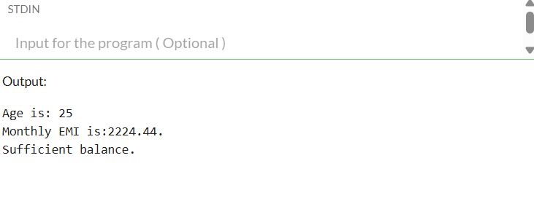

**Exercise 4:Triggers**

**Scenario 1:**

CREATE OR REPLACE TRIGGER UpdateCustomerLastModified

BEFORE UPDATE ON Customers

FOR EACH ROW

BEGIN

:NEW.LastModified := SYSDATE;

END;

/

Scenario2:

CREATE OR REPLACE TRIGGER LogTransaction

AFTER INSERT ON Transactions

FOR EACH ROW

BEGIN

INSERT INTO AuditLog (TransactionID, AccountID, Type, Amount)

VALUES (:NEW.TransactionID, :NEW.AccountID, :NEW.Type, :NEW.Amount);

END;

/

Scenario3:

CREATE OR REPLACE TRIGGER CheckTransactionRules

BEFORE INSERT ON Transactions

FOR EACH ROW

DECLARE

v_balance NUMBER;

BEGIN

-- Get current balance

SELECT Balance INTO v_balance FROM Customers WHERE CustomerID = :NEW.AccountID;

-- Check deposit

IF :NEW.Type = 'Deposit' AND :NEW.Amount <= 0 THEN

RAISE_APPLICATION_ERROR(-20001, 'Deposit amount must be positive.');

END IF;

-- Check withdrawal

IF :NEW.Type = 'Withdrawal' AND :NEW.Amount > v_balance THEN

RAISE_APPLICATION_ERROR(-20002, 'Insufficient balance for withdrawal.');

END IF;

END;

/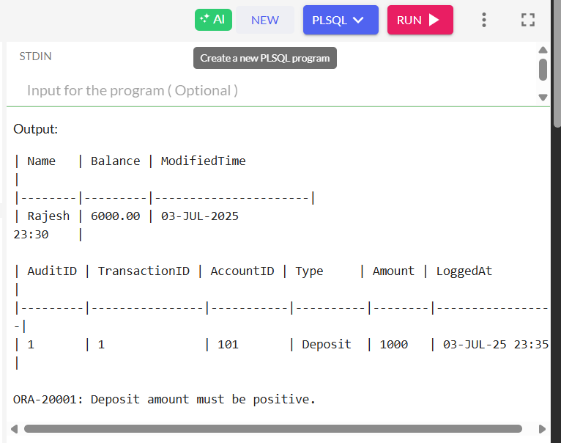

**Exercise 6: Cursors:**

**Scenario1:**

**SET SERVEROUTPUT ON;**

DECLARE

CURSOR txn_cursor IS

SELECT c.CustomerID, c.Name, t.Amount, t.TxnType, t.TxnDate

FROM Customers c

JOIN Transactions t ON c.CustomerID = t.CustomerID

WHERE TRUNC(t.TxnDate, 'MM') = TRUNC(SYSDATE, 'MM');

v_custID Customers.CustomerID%TYPE;

v_name Customers.Name%TYPE;

v_amount Transactions.Amount%TYPE;

v_type Transactions.TxnType%TYPE;

v_date Transactions.TxnDate%TYPE;

BEGIN

OPEN txn_cursor;

LOOP

FETCH txn_cursor INTO v_custID, v_name, v_amount, v_type, v_date;

EXIT WHEN txn_cursor%NOTFOUND;

DBMS_OUTPUT.PUT_LINE('Customer: ' || v_name ||

', Type: ' || v_type ||

', Amount: ₹' || v_amount ||

', Date: ' || TO_CHAR(v_date, 'DD-MON-YYYY'));

END LOOP;

CLOSE txn_cursor;

END;

/

Scenario2:

SET SERVEROUTPUT ON;

DECLARE

CURSOR acc_cursor IS

SELECT AccountID, Balance FROM Accounts;

v_accID Accounts.AccountID%TYPE;

v_balance Accounts.Balance%TYPE;

v_fee CONSTANT NUMBER := 500;

BEGIN

OPEN acc_cursor;

LOOP

FETCH acc_cursor INTO v_accID, v_balance;

EXIT WHEN acc_cursor%NOTFOUND;

IF v_balance >= v_fee THEN

UPDATE Accounts SET Balance = Balance - v_fee WHERE AccountID = v_accID;

DBMS_OUTPUT.PUT_LINE('₹' || v_fee || ' fee deducted from Account ID: ' || v_accID);

ELSE

DBMS_OUTPUT.PUT_LINE('Insufficient balance in Account ID: ' || v_accID || '. Fee not deducted.');

END IF;

END LOOP;

CLOSE acc_cursor;

COMMIT;

END;

/

Scenario3:

SET SERVEROUTPUT ON;

DECLARE

CURSOR loan_cursor IS

SELECT LoanID, LoanAmount FROM Loans;

v_loanID Loans.LoanID%TYPE;

v_amount Loans.LoanAmount%TYPE;

v_newRate NUMBER(5,2);

BEGIN

OPEN loan_cursor;

LOOP

FETCH loan_cursor INTO v_loanID, v_amount;

EXIT WHEN loan_cursor%NOTFOUND;

IF v_amount < 100000 THEN

v_newRate := 10;

ELSIF v_amount <= 500000 THEN

v_newRate := 8;

ELSE

v_newRate := 7;

END IF;

UPDATE Loans SET InterestRate = v_newRate WHERE LoanID = v_loanID;

DBMS_OUTPUT.PUT_LINE('Loan ID ' || v_loanID || ' updated to interest rate: ' || v_newRate || '%');

END LOOP;

CLOSE loan_cursor;

COMMIT;

END;

/

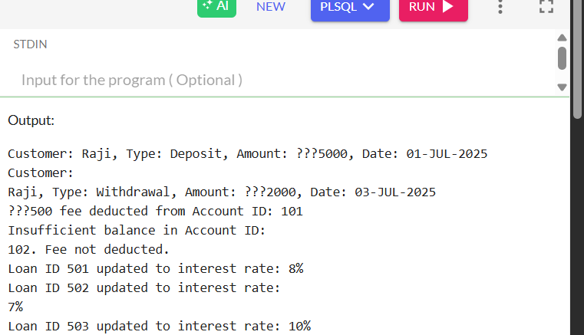

**Exercise 7: Packages:**

CREATE OR REPLACE PACKAGE CustomerManagement AS

PROCEDURE AddCustomer(p_ID NUMBER, p_Name VARCHAR2, p_DOB DATE, p_Balance NUMBER);

PROCEDURE UpdateCustomer(p_ID NUMBER, p_Name VARCHAR2, p_Balance NUMBER);

FUNCTION GetCustomerBalance(p_ID NUMBER) RETURN NUMBER;

END CustomerManagement;

/

CREATE OR REPLACE PACKAGE BODY CustomerManagement AS

PROCEDURE AddCustomer(p_ID NUMBER, p_Name VARCHAR2, p_DOB DATE, p_Balance NUMBER) IS

BEGIN

INSERT INTO Customers (CustomerID, Name, DOB, Balance, LastModified)

VALUES (p_ID, p_Name, p_DOB, p_Balance, SYSDATE);

DBMS_OUTPUT.PUT_LINE('Customer added: ' || p_Name);

END;

PROCEDURE UpdateCustomer(p_ID NUMBER, p_Name VARCHAR2, p_Balance NUMBER) IS

BEGIN

UPDATE Customers

SET Name = p_Name, Balance = p_Balance, LastModified = SYSDATE

WHERE CustomerID = p_ID;

DBMS_OUTPUT.PUT_LINE('Customer updated: ' || p_Name);

END;

FUNCTION GetCustomerBalance(p_ID NUMBER) RETURN NUMBER IS

v_balance NUMBER;

BEGIN

SELECT Balance INTO v_balance FROM Customers WHERE CustomerID = p_ID;

RETURN v_balance;

END;

END CustomerManagement;

/

SET SERVEROUTPUT ON;

BEGIN

CustomerManagement.AddCustomer(3, 'Meena Kumari', TO_DATE('1995-12-01', 'YYYY-MM-DD'), 2000);

CustomerManagement.UpdateCustomer(3, 'Meena Kumari', 2500);

DBMS_OUTPUT.PUT_LINE('Balance: ₹' || CustomerManagement.GetCustomerBalance(3));

END;

/

Scenario 2:

CREATE OR REPLACE PACKAGE EmployeeManagement AS

PROCEDURE HireEmployee(p_ID NUMBER, p_Name VARCHAR2, p_Position VARCHAR2, p_Salary NUMBER, p_Dept VARCHAR2, p_HireDate DATE);

PROCEDURE UpdateEmployee(p_ID NUMBER, p_Salary NUMBER);

FUNCTION CalculateAnnualSalary(p_ID NUMBER) RETURN NUMBER;

END EmployeeManagement;

/

CREATE OR REPLACE PACKAGE BODY EmployeeManagement AS

PROCEDURE HireEmployee(p_ID NUMBER, p_Name VARCHAR2, p_Position VARCHAR2, p_Salary NUMBER, p_Dept VARCHAR2, p_HireDate DATE) IS

BEGIN

INSERT INTO Employees (EmployeeID, Name, Position, Salary, Department, HireDate)

VALUES (p_ID, p_Name, p_Position, p_Salary, p_Dept, p_HireDate);

DBMS_OUTPUT.PUT_LINE('Employee hired: ' || p_Name);

END;

PROCEDURE UpdateEmployee(p_ID NUMBER, p_Salary NUMBER) IS

BEGIN

UPDATE Employees SET Salary = p_Salary WHERE EmployeeID = p_ID;

DBMS_OUTPUT.PUT_LINE('Employee salary updated.');

END;

FUNCTION CalculateAnnualSalary(p_ID NUMBER) RETURN NUMBER IS

v_salary NUMBER;

BEGIN

SELECT Salary INTO v_salary FROM Employees WHERE EmployeeID = p_ID;

RETURN v_salary * 12;

END;

END EmployeeManagement;

/

BEGIN

EmployeeManagement.HireEmployee(3, 'Ravi Kumar', 'Analyst', 55000, 'Finance', TO_DATE('2020-08-01', 'YYYY-MM-DD'));

EmployeeManagement.UpdateEmployee(3, 58000);

DBMS_OUTPUT.PUT_LINE('Annual Salary: ₹' || EmployeeManagement.CalculateAnnualSalary(3));

END;

/

Scenario 3:

CREATE OR REPLACE PACKAGE AccountOperations AS

PROCEDURE OpenAccount(p_ID NUMBER, p_CustomerID NUMBER, p_Type VARCHAR2, p_Balance NUMBER);

PROCEDURE CloseAccount(p_ID NUMBER);

FUNCTION GetTotalBalance(p_CustomerID NUMBER) RETURN NUMBER;

END AccountOperations;

/

CREATE OR REPLACE PACKAGE BODY AccountOperations AS

PROCEDURE OpenAccount(p_ID NUMBER, p_CustomerID NUMBER, p_Type VARCHAR2, p_Balance NUMBER) IS

BEGIN

INSERT INTO Accounts (AccountID, CustomerID, AccountType, Balance, LastModified)

VALUES (p_ID, p_CustomerID, p_Type, p_Balance, SYSDATE);

DBMS_OUTPUT.PUT_LINE('Account opened with ID: ' || p_ID);

END;

PROCEDURE CloseAccount(p_ID NUMBER) IS

BEGIN

DELETE FROM Accounts WHERE AccountID = p_ID;

DBMS_OUTPUT.PUT_LINE('Account closed: ' || p_ID);

END;

FUNCTION GetTotalBalance(p_CustomerID NUMBER) RETURN NUMBER IS

v_total NUMBER;

BEGIN

SELECT NVL(SUM(Balance), 0) INTO v_total FROM Accounts WHERE CustomerID = p_CustomerID;

RETURN v_total;

END;

END AccountOperations;

/

BEGIN

AccountOperations.OpenAccount(3, 1, 'Fixed', 7000);

AccountOperations.CloseAccount(2);

DBMS_OUTPUT.PUT_LINE('Total Balance of Customer 1: ₹' || AccountOperations.GetTotalBalance(1));

END;

/

